Module name:Manual test execution
Test case ID:TC_01
Webpage URL:www.demoblaze.com

Scenario ID:1a

Scenario:Open a website
Test steps :

(1)click on website link

Screenshots:

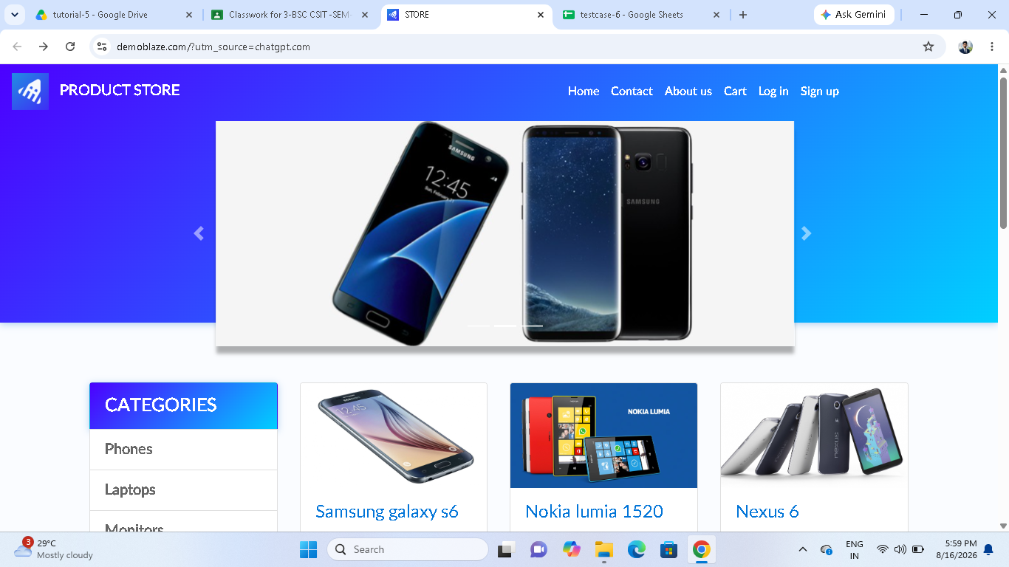

Scenario ID:1b

Scenario:Select Product
Test steps :

(1)click on product.

Screenshots:

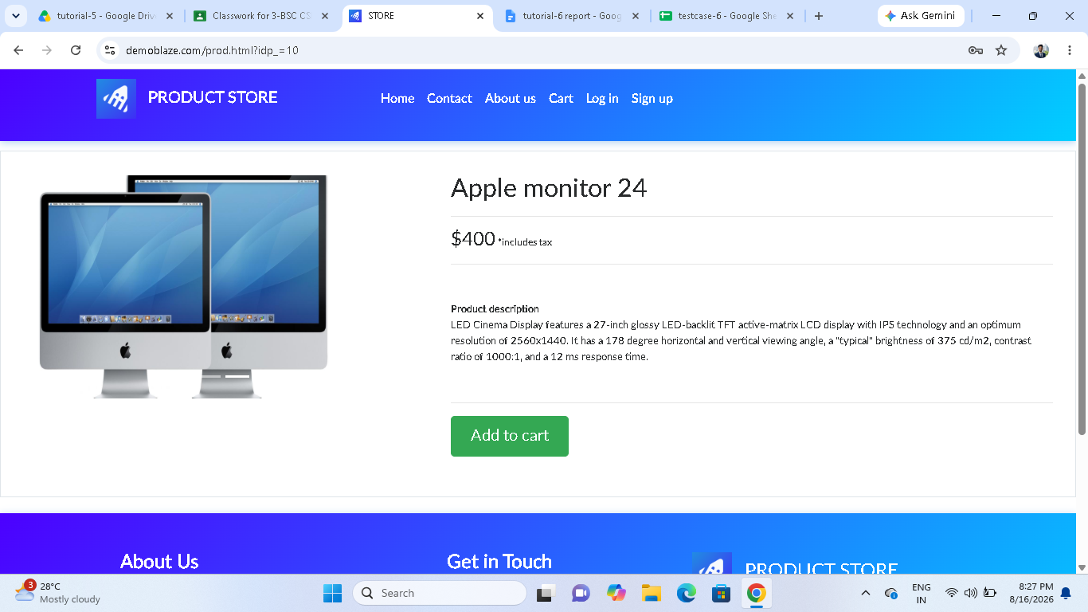

Scenario ID:1c

Scenario:Product Details
Test steps :

(1)click on product.

Screenshots:

Scenario ID:1d
Scenario:add to cart
Test steps :
(1)click on product.
(2)click on add to cart button

Screenshot:

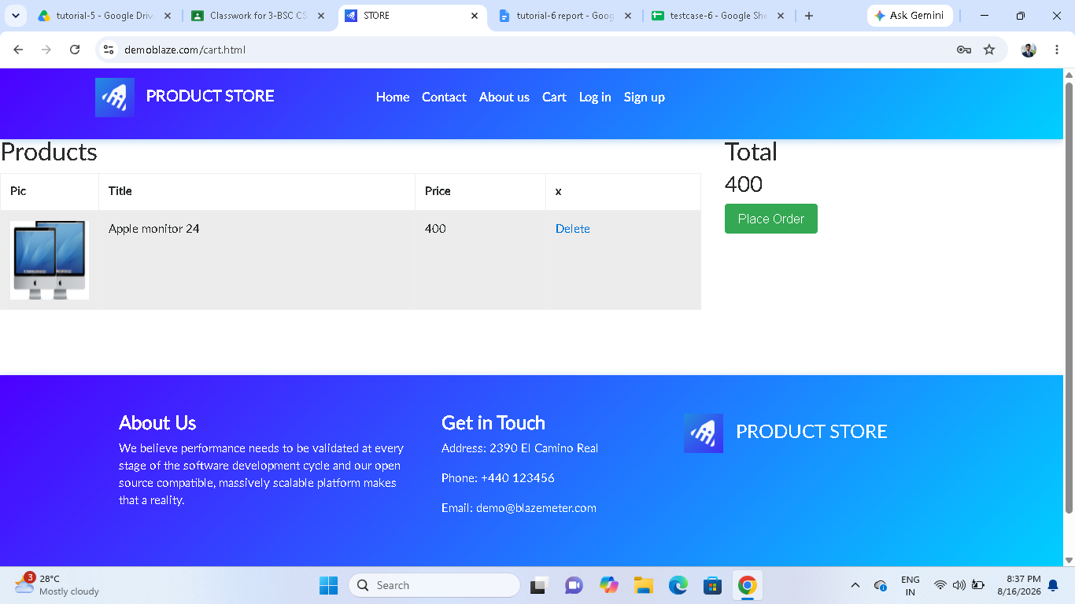

Scenario ID:1e
Scenario:Place Order
Test steps :
(1)click on add to cart button
(2)click on place order.

Screenshot:

Scenario ID:2a
Scenario:Customer Details
Test steps :
(1)click on place order .
(2)fill you details

Screenshot:

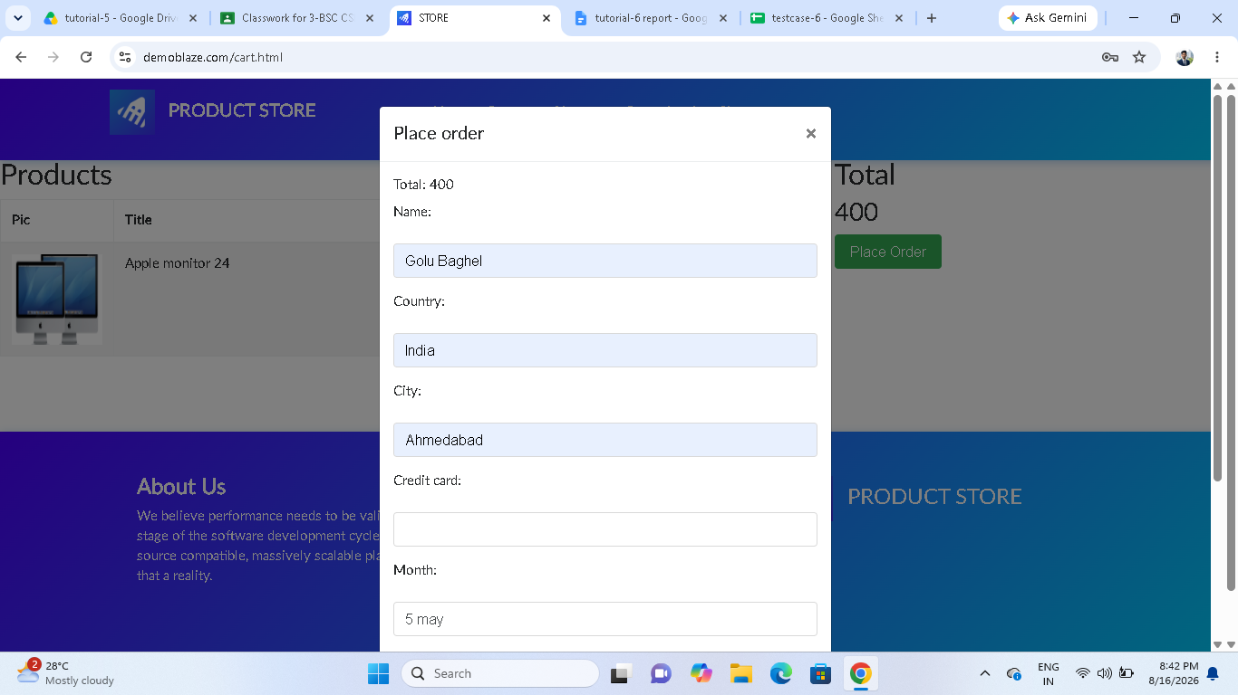

Scenario ID:2b
Scenario:Submit Order
Test steps :
(1)fill all you details
(2)click on submit button.

Screenshot:
